The History Day Website

The website category is the most interactive of all categories and is more than just a paper or exhibit put on the web. A website allows you to put a variety of information, evidence, and interactive elements in a format that is becoming increasingly popular. A website is a good choice for topics with a variety of illustrations, documents, media (music, video), and potential for interactive elements.
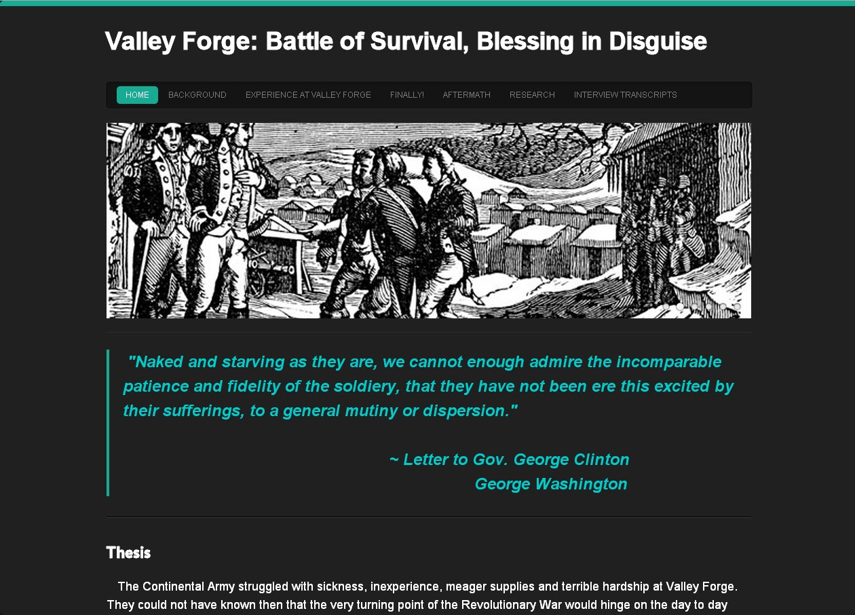
Ideal for Students who:
- enjoy working with computers and are interested in learning how to build a website.
- have access to a computer with a reliable internet connection to do a majority of the work on.

To prove your thesis, a Website includes:
- no more than 1,200 visible, student-composed words.
- a variety of information in text, illustrations, documents, and media (audio, visual).
- primary source materials
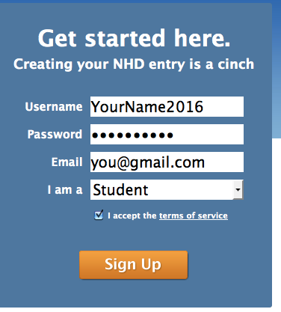
Basic Guidelines:
- Must be created and built through NHD’s Weebly portal at http://nhd.weebly.com
- Use the site-building tools available on the NHD Weebly portal. If components are created using a third-party tool (i.e. Dreamweaver, iWeb, MS Expression), they must be portable to and function correctly with the Weebly editor. All hosting will be performed by Weebly servers.
- The site must not exceed 100 MB.
- The website must “stand alone” and not rely on student to explain it. Be sure the images, written materials, and illustrations are easy for the viewer to understand.
- The title should be the main focus and centered.
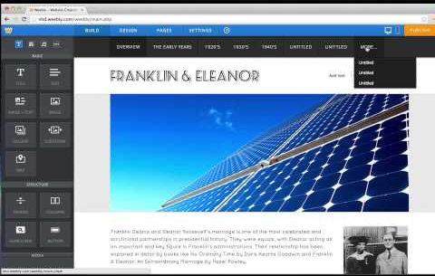
- A strong thesis clearly stated and obvious for viewer to see.
- You may only have 1,200 of your own words, including titles, subtitles, thesis, captions, descriptions, etc.
- All images need to include URL address to credit the source.
- All quoted material needs to include the source.

For sample websites, visit:
http://www.nhd.org/StudentProjectExamples.htm
and scroll down to Websites
History Day WEBSITE Scoring Rubric

Student Name: _____________________________________ Title of Exhibit: _______________________________________
Comments/Suggestions:
 | Superior | Excellent | Good | Needs Improvement
Historical Quality - 60% | 10 | 9 | 8 | 7-5
- historically accurate
- shows analysis and interpretation
- places topic in historical context
- shows wide research
- uses available primary sources
- research is balanced & addresses opposing viewpoints
Relation to “Leadership & Legacy” Theme - 20%
- clearly relates topic to theme with strong thesis statement
- demonstrates significance of topic (importance) & draws conclusions that prove thesis statement
Clarity of Presentation - 30%
- Clearly Organized: website material is original, clear, appropriate, and well-organized for optimal viewer understanding
- Visually Appealing: has visual impact that enhances viewer interest with use of color, images, objects, and written material
Rule Requirements Met:
- within size limit of 100 MB
- within 1,200 word limit for student’s wording
- multimedia clips within time limit of 45 seconds per clip
FINAL SCORE

