The History Day Performance

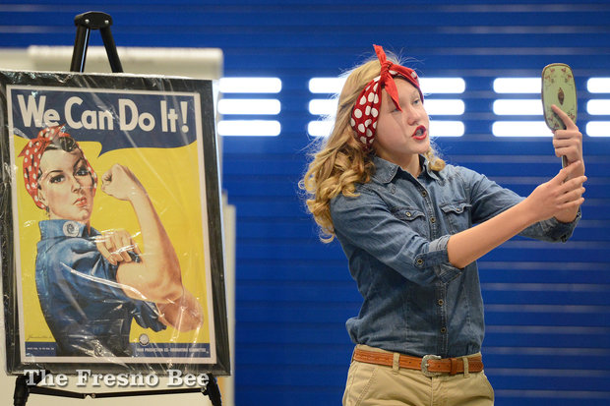
A performance category allows you to create a historical play with dramatic appeal, but not at the expense of historical information. Performances are not simply oral reports. You will write a script, choose costumes, and develop characters to convey your thesis.

Ideal for Students who:
- are interested in drama and enjoy being on stage.
- are willing to memorize lines and perform “live.”

To prove your thesis, a Performance includes:
- a well-planned and memorized narrative script.
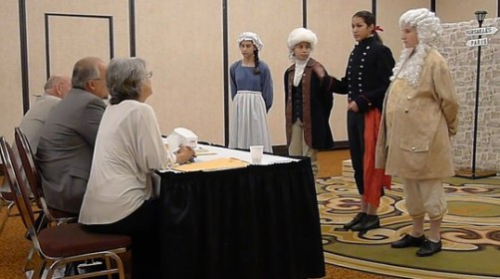
- characters and scenes that present the thesis and prove it to an audience.
- simple but effective props that establish the setting and help audience follow the events.

Basic Guidelines:
- Must be an original production.
- Must fit within 10-minute time limit.
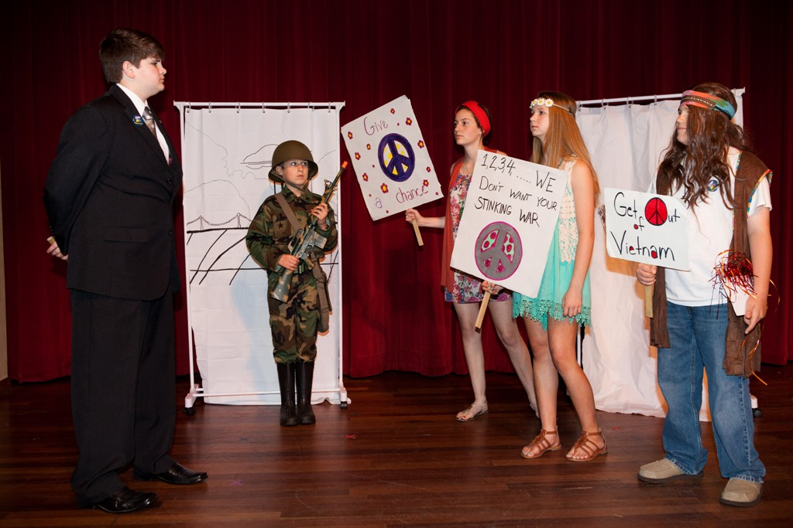
- All set and props must be set up by performer(s) and done within 10 minutes before performance & taken down within 5 minutes after.
- Create an attention-grabbing opening that clearly introduces your strong thesis to the audience.
- Include conflict & resolution in your narrative.
- Include a strong conclusion at the end that reinforces your thesis and the impact of your performance. It’s what you leave the audience with… make it lasting.
- Carefully consider your props and audio/visual aids. What are the pros and cons, as you will be responsible for all preparation and technical support.
- Memorization is only the first step… you must also perform your script and bring it to life. Your goal is to make the lines sound as if they are fresh thoughts, occurring at the moment they are spoken in response to the actions and words that precede them. Practicing your lines aloud as often as you can will help you achieve the right inflection and tone. Listen to yourself and have others listen to you and provide feedback on your delivery.
- To block a performance is to determine where the actors will stand, move, and relate to the set. Be aware of the movement you will be making and plan your set accordingly.
- Practice makes perfect, so practice, practice, practice! Work on delivery, speaking clearly and pronouncing all words correctly. Practice with the set and full costumes as often as possible.

Search NHD Performances on YouTube for sample performances.

History Day PERFORMANCE Scoring Rubric

Student Name: _____________________________________ Title of Exhibit: _______________________________________
Comments/Suggestions:
 | Superior | Excellent | Good | Needs Improvement
Historical Quality - 60% | 10 | 9 | 8 | 7-5
- historically accurate
- shows analysis and interpretation
- places topic in historical context
- shows wide research
- uses available primary sources
- research is balanced & addresses opposing viewpoints
Relation to “Leadership & Legacy” Theme - 20%
- clearly relates topic to theme with strong thesis statement
- demonstrates significance of topic (importance) & draws conclusions that prove thesis statement
Clarity of Presentation - 30%
- Clearly Organized: exhibit material is original, clear, appropriate, and well-organized for optimal viewer understanding
- Visually Appealing: has visual impact that enhances viewer interest with use of color, images, objects, and written material
Rule Requirements Met:
- within 10-minute time limit
- all set-up and equipment is student-run
FINAL SCORE

