The History Day Exhibit

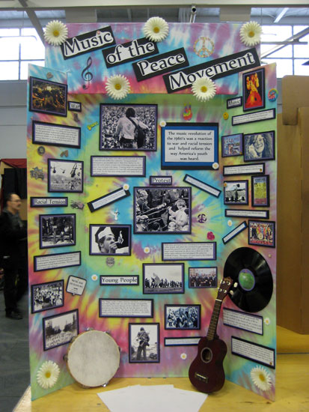
An exhibit is a visual representation of your research, much a small version like you would see in a museum. The information should be displayed in an easy-to-understand and attractive manner that uses a variety of text and illustrations as support for your argument.

Ideal for Students who:
- enjoy creating things with their hands and visually building an argument.
- have access to creative supplies, including a poster board, colorful paper, a color printer, glue, scissors, paint, etc.

To prove your thesis, an Exhibit includes:
- only 500 of your own words, contained in titles, headlines, captions, timeline, and description.
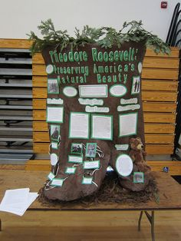
- a variety of items you did not write -- newspaper articles, letters, documents, quotes, etc. -- especially from primary sources.
- photographs and other illustrative materials (like cartoons, charts, artwork, 3-D objects).

Basic Guidelines:
- The overall size when displayed must be no larger than 40 inches wide, 30 inches deep, and 6 feet high.
- The exhibit must “stand alone” and not rely on student to explain it. Be sure the images, written materials, and illustrations are easy to understand.
- The title should be the main focus and centered.
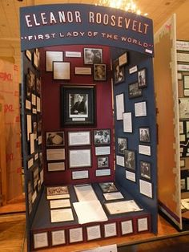
- A strong thesis clearly stated and obvious for viewer to see.
- You may only have 500 of your own words, including titles, subtitles, thesis, captions, descriptions, etc.
- The center panel should contain the main ideas of your topics leadership. Side panels are best used to explain related details, such as the context and legacy.
- Artifacts or other materials may be displayed on the table between the side panels as part of the exhibit.
- All images need to include URL address to credit the source.
- All quoted material needs to include the source.
- Must be student-constructed and student must be able to complete all set-up on their own. Adults may supervise steps of construction.

Google images of NHD Exhibits for more samples of exhibits.

History Day EXHIBIT Scoring Rubric

Student Name: _____________________________________ Title of Exhibit: _______________________________________
Comments/Suggestions:
 | Superior | Excellent | Good | Needs Improvement
Historical Quality - 60% | 10 | 9 | 8 | 7-5
- historically accurate
- shows analysis and interpretation
- places topic in historical context
- shows wide research
- uses available primary sources
- research is balanced & addresses opposing viewpoints
Relation to “Leadership & Legacy” Theme - 20%
- clearly relates topic to theme with strong thesis statement
- demonstrates significance of topic (importance) & draws conclusions that prove thesis statement
Clarity of Presentation - 30%
- Clearly Organized: exhibit material is original, clear, appropriate, and well-organized for optimal viewer understanding
- Visually Appealing: has visual impact that enhances viewer interest with use of color, images, objects, and written material
Rule Requirements Met:
- within size limit (40” wide, 30” deep, 6’ tall)
- within 500 word limit for student’s wording
- media device - 3 minute time limit
FINAL SCORE

