The History Day Documentary

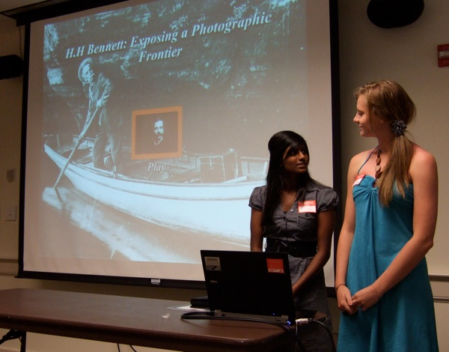
A documentary presents information through a 10-minute presentation that showcases documents, images, photographs, and actual footage of the topic you are researching. This is your chance to make you own TV-style documentary using computer-based video editing programs.

Ideal for Students who:
- are interested in working with computers and documentary technology.
- have access to video-editing programs such as iMovie, Windows Moviemaker, or Adobe Premiere on a computer or laptop at home, as well as reliable internet access.
- have a topic with a variety of illustrations, documents, media, and other visual materials.

To prove your thesis, a Documentary includes:
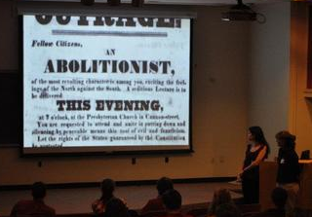
- many visuals, including still images and video.
- narration by the student.
- additional audio, like music and interviews.
- credits at the end that are included in the 10-minute time limit.

Basic Guidelines:
- Entire documentary, including credits, must fit within 10-minute time limit.
- Must be student-produced. All narration and live video performance/reenactments must be by student(s) in this project.
- Use iMovie (on Macs), Windows Moviemaker (free download), or Adobe Premiere to create your movie. You may use Powerpoint slideshow, although you will need to put extra effort into designing a presentation that combines visual images and recorded narrative effectively.
- Write the script before you start creating the documentary. Record the narration first, and then insert visuals to support it.
- Make sure you have enough visuals -- 10 minutes is 600 seconds, and the average time a picture is on screen is 5 seconds. This means you’ll need over 100 images! Of course, video clips will help fill this more quickly.
  - Places to go for visuals: scan from books, take digital photos of books/photos, Google Images, take video from documentaries (video is okay to take, but not narration).
- A strong thesis clearly stated and obvious for viewer to see.
- Include an interview, or a few. You may find clips of eyewitness interviews, historians, authors, or even your own topic person online. If possible, you may interview an expert yourself!
- All images need to include URL address in credits.
- All quoted material needs to include the source.

Search NHD Documentaries on YouTube for samples.

History Day DOCUMENTARY Scoring Rubric

Student Name: _____________________________________ Title of Exhibit: _______________________________________
Comments/Suggestions:
 | Superior | Excellent | Good | Needs Improvement
Historical Quality - 60% | 10 | 9 | 8 | 7-5
- historically accurate
- shows analysis and interpretation
- places topic in historical context
- shows wide research
- uses available primary sources
- research is balanced & addresses opposing viewpoints
Relation to “Leadership & Legacy” Theme - 20%
- clearly relates topic to theme with strong thesis statement
- demonstrates significance of topic (importance) & draws conclusions that prove thesis statement
Clarity of Presentation - 30%
- Clearly Organized: exhibit material is original, clear, appropriate, and well-organized for optimal viewer understanding
- Visually Appealing: has visual impact that enhances viewer interest with use of color, images, objects, and written material
Rule Requirements Met:
- within 10-minute time limit
- includes credits listing image sources
- all equipment is student-run
FINAL SCORE

